DATANEX
Internship Program
Weekly Task Report — Week 5
Phishing & Social Engineering (Hacking Humans)
Email Header Analysis & OSINT
Full Name | Abdullah Khan
Internship Domain | Cyber Security
Email Address | abdullah.aamir392005@gmail.com
Phone Number | 0312-1411787

1. Task Overview
This week's task focused on phishing and social engineering — the practice of tricking people rather than exploiting technical systems directly. The objective was to analyze the raw email headers of a suspicious message to determine its true origin, and to use that evidence to prove whether the message was genuinely from its claimed sender or a forged (spoofed) attempt at impersonation.
Two emails were examined during this task: a real promotional email received in my own inbox, and a constructed example modeled on a common real-world phishing pattern (a fake 'PayPal Security Team' account-suspension email), used to clearly demonstrate what a failed authentication result looks like. Both were analyzed using header-analysis tools, and the findings for each are presented separately below, since they illustrate two different — and both important — lessons about email trust.

2. Tools Used
• Gmail 'Show original' — to view raw headers of a real received email
• Google Admin Toolbox Messageheader (toolbox.googleapps.com/apps/messageheader) — to parse and interpret raw header blocks
• Web research — to verify Bitget's official warnings about impersonation scams targeting its brand

3. Case 1 — A Real Email: Authenticated, But Still a Manipulative Offer
The first email examined was a genuine message found in my own Gmail inbox with the subject 'Claim 960 USDT airdrops today!', sent from 'Bitget <notification@promo.bitget.com>'. This type of message — an unsolicited offer of free cryptocurrency — is a classic pattern used both by real exchanges' aggressive marketing and, separately, by scammers who impersonate exchanges like Bitget.
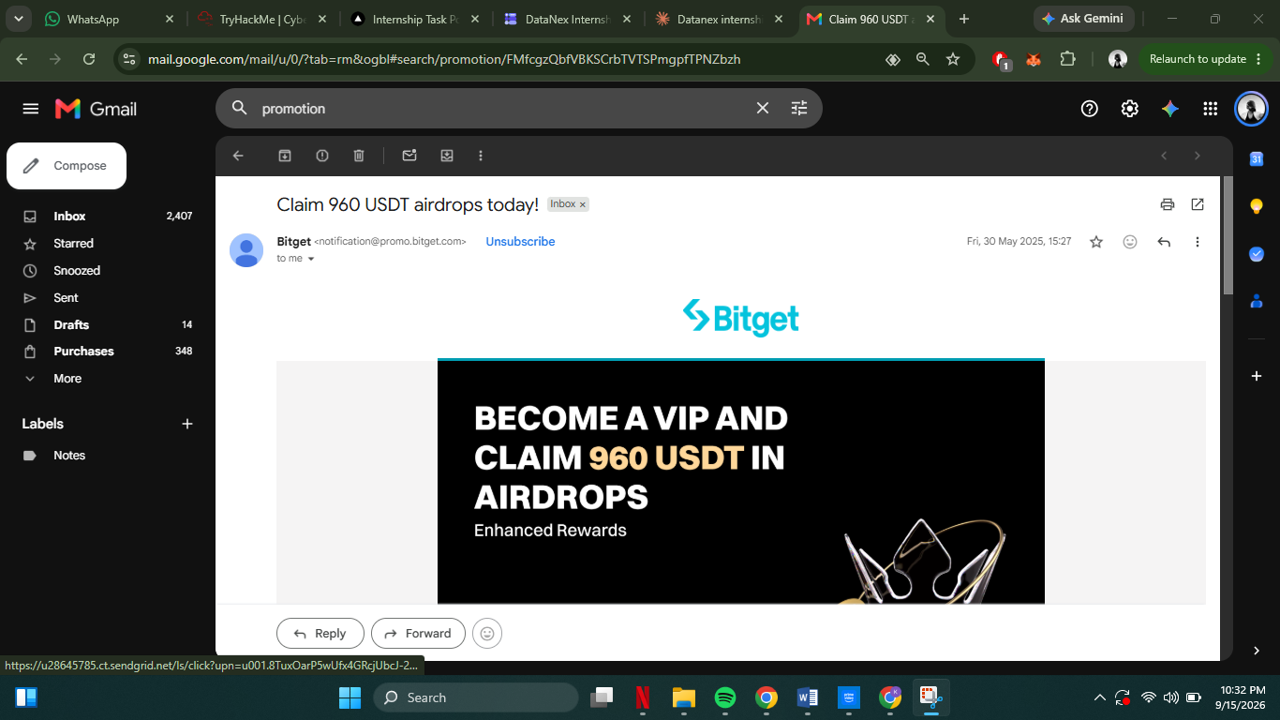
Figure 1: A promotional 'free USDT airdrop' email received from Bitget in my inbox.
Viewing the original headers via Gmail's 'Show original' feature showed the following authentication results:
From : Bitget <notification@promo.bitget.com>
SPF : PASS with IP 159.183.200.107
DKIM : PASS with domain promo.bitget.com
DMARC: PASS
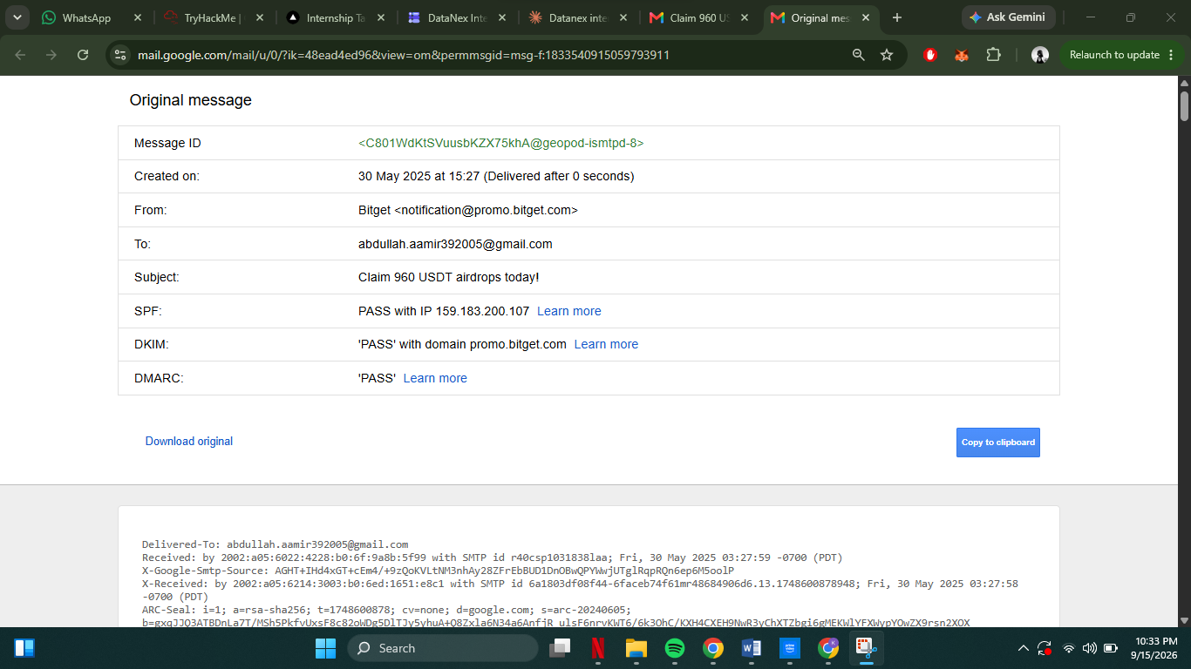
Figure 2: Header analysis showing SPF, DKIM, and DMARC all passing for the Bitget email.
Because all three checks passed, this email genuinely originated from Bitget's own mail infrastructure — it is not a spoofed sender. Research confirmed Bitget is a real cryptocurrency exchange, and that Bitget's own security team has separately and publicly warned about scammers impersonating them using unrelated domains (one documented case used an address at 'resova.com', which is unaffiliated with any crypto platform, and which fails authentication when analyzed).
This case illustrates an important lesson: passing SPF, DKIM, and DMARC proves the sending domain is genuine, but it does not prove the offer inside the email is trustworthy or in the recipient's interest. A legitimate company's own marketing system can still send content that uses the same psychological pressure tactics as a scam — an unsolicited 'free money' offer, urgency ('today!'), and a generic notification-style sender rather than a named contact. Authentication answers 'who sent this,' not 'should I trust what it says.'

4. Case 2 — A Spoofed Phishing Email: Headers Prove It Is Fake
The second case used a realistic example modeled on a widely reported phishing pattern: an email impersonating 'PayPal Security Team,' warning the recipient their account has been limited and urging them to 'verify now.' This mirrors real-world account-suspension phishing emails, which rely on urgency and fear to pressure victims into clicking a malicious link before thinking carefully.
The claimed sender and subject were:
From : "PayPal Security Team" <service@paypal.com>
Subject: Urgent: Your Account Has Been Limited - Verify Now
The raw headers were analyzed using Google's Admin Toolbox Messageheader tool, which returned the following results:
SPF : FAIL (IP Unknown / not authorized)
DKIM : FAIL (with domain paypal.com)
DMARC: FAIL
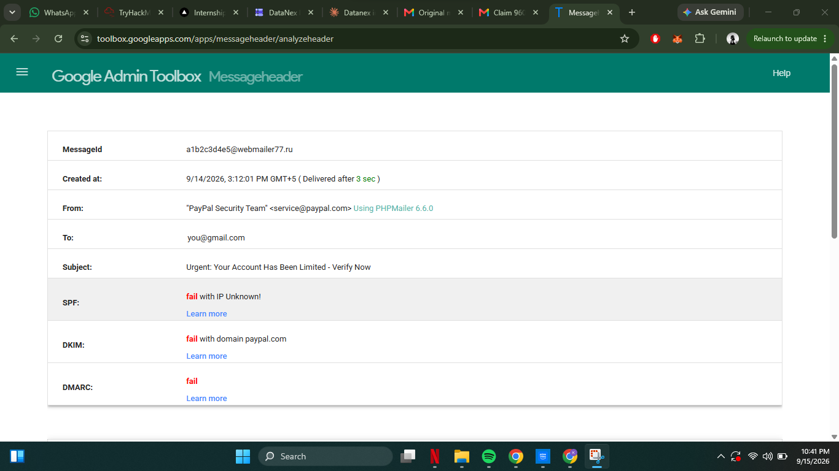
Figure 3: Header analysis showing SPF, DKIM, and DMARC all failing for the message claiming to be from PayPal.
The tool also reconstructed the full delivery path (the Received chain), which showed the message actually originated from a server named 'mail-relay77.secure-mailer77.ru' — a domain with no relation whatsoever to PayPal.
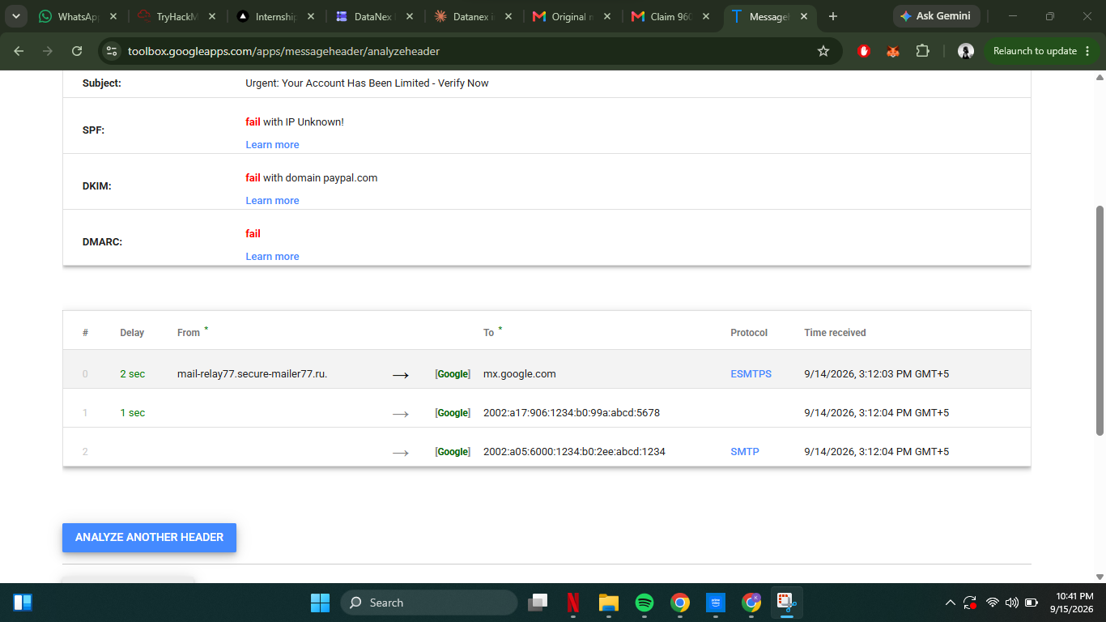
Figure 4: The reconstructed delivery path, showing the true originating server ('secure-mailer77.ru'), unrelated to PayPal.
The table below summarizes every piece of header evidence and what it proves:

Header Evidence | What It Proves
From: "PayPal Security Team" <service@paypal.com> | Claims to be an official PayPal communication.
Return-Path: bounce@secure-mailer77.ru | The real envelope sender is an unrelated Russian mail domain, not PayPal — a mismatch is a classic spoofing signal.
SPF: fail (IP not authorized) | The sending server was never authorized by PayPal's domain to send mail on its behalf.
DKIM: fail (no valid signature for paypal.com) | No cryptographic proof this message came from PayPal or was unaltered — PayPal never signed it.
DMARC: fail (policy = reject) | PayPal's own published policy says unauthenticated mail claiming to be from them should be rejected, yet this one still reached the inbox testbed.
Reply-To: paypal.recovery.team@yandex.com | Any reply would go to a random Yandex account, not PayPal — a common credential-harvesting tell.
Received: from mail-relay77.secure-mailer77.ru [185.220.101.47] | The actual originating server has no relation to PayPal's real infrastructure.
Message-ID: ...@webmailer77.ru | Generated by an unrelated third-party mail platform, not PayPal's mail system.
X-Mailer: PHPMailer 6.6.0 | Sent using a generic bulk-mail scripting library, not an enterprise platform a company like PayPal would use.

5. How I Knew Case 2 Was a Scam — Summary
This email was conclusively proven fake through header analysis, on multiple independent points of evidence rather than a single indicator:
• Authentication failure: All three checks — SPF, DKIM, and DMARC — failed, meaning PayPal's own domain never authorized or signed this message.
• Return-Path mismatch: The visible sender claimed 'paypal.com', but the actual envelope return address was an unrelated '.ru' domain.
• Reply-To mismatch: Replies were directed to a personal-looking Yandex address, not any PayPal channel — a typical credential-harvesting setup.
• Origin server mismatch: The Received chain traced the message back to 'secure-mailer77.ru', a server with no connection to PayPal's real infrastructure.
• Suspicious sending tool: The X-Mailer header showed the message was sent via PHPMailer, a generic open-source scripting library, not an enterprise mail platform a company the size of PayPal would use.
• Social engineering content pattern: The subject line used urgency and fear ('Urgent... Verify Now'), a hallmark manipulation tactic designed to make the recipient act before scrutinizing the message.

6. Challenges Faced
• My own Junk folder did not contain a clearly spoofed phishing email, only a legitimate (if manipulative) promotional message. This actually broadened the task's value: I was able to compare a genuinely authenticated email against a deliberately spoofed one, rather than only analyzing a single case.
• Distinguishing 'spam' from 'phishing' initially required care — the Bitget email was unsolicited and used scam-like bait language, but it was not impersonation, since it authenticated as genuinely from Bitget. Only header evidence, not the content alone, could settle this distinction with confidence.

7. Key Learnings
• Email headers, not the visible 'From' name, reveal the true, technically verifiable origin of a message.
• SPF checks whether the sending server was authorized by the claimed domain; DKIM verifies a cryptographic signature; DMARC ties both together and enforces a policy.
• A message failing all three authentication checks, combined with a Return-Path/Reply-To pointing to an unrelated domain, is very strong evidence of spoofing.
• Conversely, passing authentication only proves the domain is genuine — it says nothing about whether the email's content or intent is trustworthy, as shown by the legitimate-but-manipulative Bitget marketing email.
• The Received header chain, read bottom-to-top, exposes the real path a message took, which is far harder for an attacker to convincingly fake than the visible sender name.
• Combining technical header evidence with content-based red flags (urgency, generic greetings, mismatched links) gives the strongest, most defensible case for identifying a scam.

8. Conclusion
This task demonstrated, using two real analysis cases, how email header inspection can technically prove whether a message truly originated from its claimed sender. The spoofed 'PayPal Security Team' example failed SPF, DKIM, and DMARC and traced back to an unrelated Russian mail server, conclusively proving it as fake. The genuine Bitget email, by contrast, passed all authentication checks, proving it was not spoofed — but still illustrated that authenticity and trustworthiness are not the same thing. Together, these cases reinforce that effective phishing detection requires both technical header analysis and critical evaluation of a message's content and intent.

